 **MATHEMATICS APPLICATIONS**

**Test 2 2017-2018**

**Linear Functions**

**Resource Free**

**Marks: 47 Time Allowed: 50 minutes**

**TOTAL: 47 Name: _______________**

**ALL** working must be shown for full marks.

**For full marks you will need to show all your working out.**

**Question 1** **[2,2,3,3,3,3 = 16 marks]**

1. Solve the following Linear functions

**i)** 4y - 6 = 30 **ii)** 4x + 12 = 3x + 6

**iii)** 3(x + 8) - 2 = 7 **iv)** 2x + 8 = -3(x + 2)

1. **Give the equation** that represents the following situations and **then solve** to find the value of x.
2. “Three times a number is divided by four and then two is added. The result is one less than the original number”
3. “Twice a number divided by three subtracted from 10 results in four minus a number divided by 2”

**Question 2 [3,3,1,2 : 9 marks]**

For the tables and graphs given below

**i)** Decide if a linear relationship is shown.

**ii)** If table or graph is linear, give the linear equation.

|  |  |  |  |  |  |
| --- | --- | --- | --- | --- | --- |
| **x** | -2 | -1 | 0 | 1 | 2 |
| **y** | 5 | 8 | 11 | 14 | 17 |

**a)**

Linear: Yes / No

Rule:

**b)**

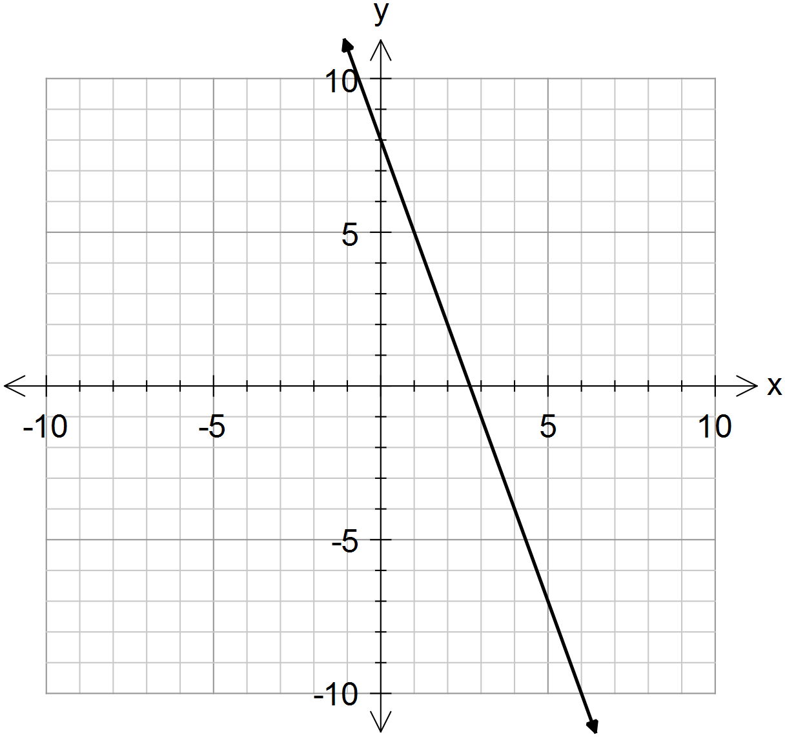

Linear: Yes / No

Rule:

|  |  |  |  |  |  |
| --- | --- | --- | --- | --- | --- |
| **x** | 2 | -1 | 1 | 0 | -2 |
| **y** | 10 | 12 | 14 | 16 | 18 |

**c)**

Linear: Yes / No

Rule:

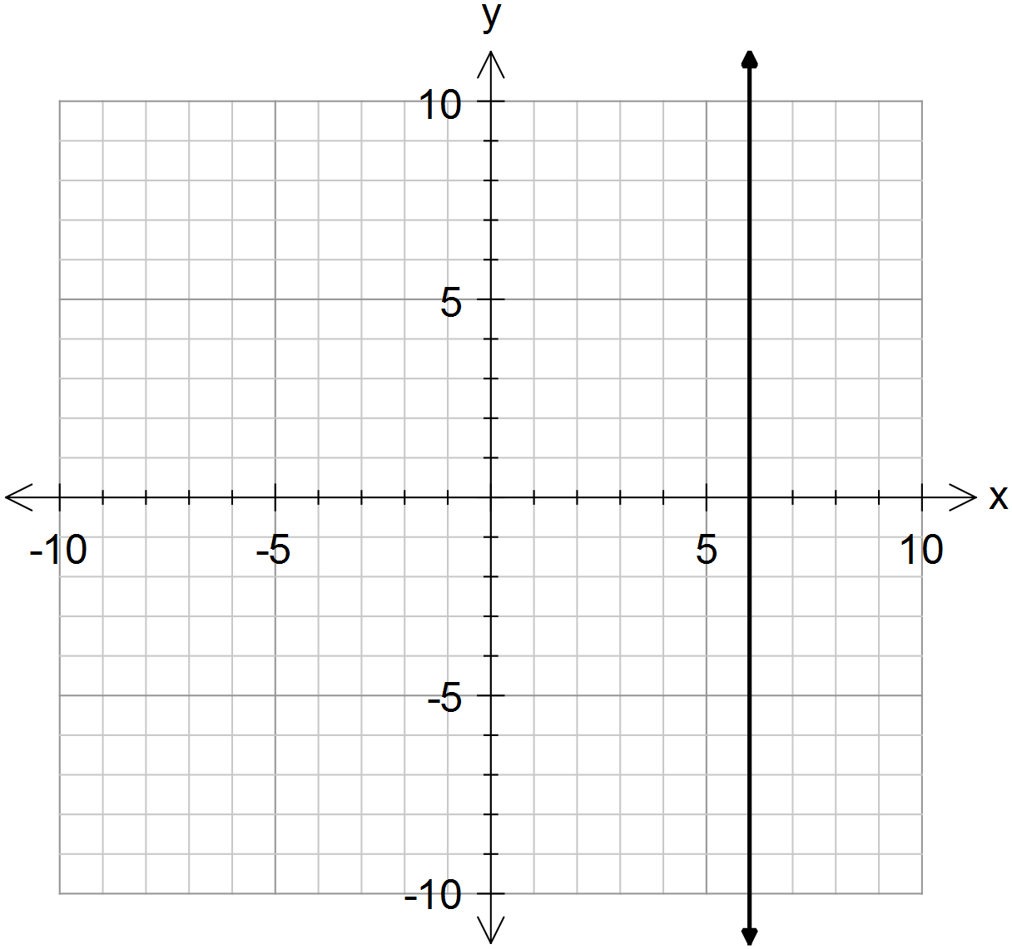

**d)**

Linear: Yes / No

Rule:

**Question 3** **[ 2, 2, 3 = 7 marks]**

1. For the function y = - 4x – 4, give the gradient and y intercept.
2. For the function 3x - 2y = 30, give the x-intercept and y intercept.
3. Sketch the functions above on the following axis. (must be ruled)

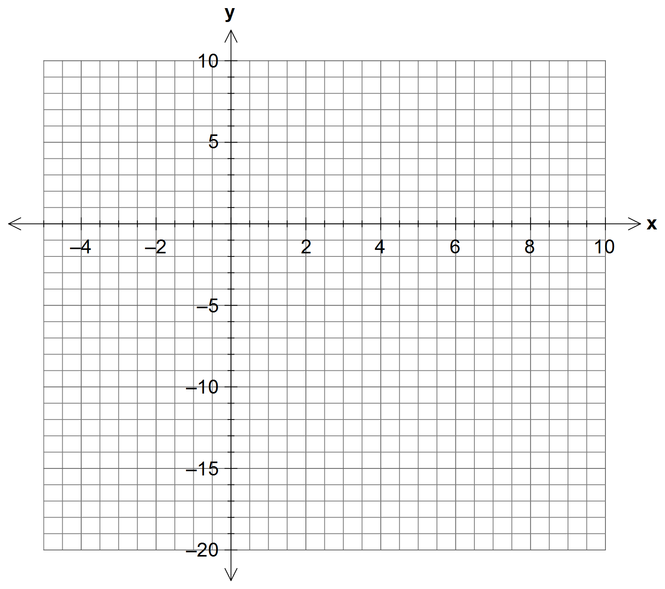

**Question 4 [1,2,2,1,3,2,4 = 15 marks]**

Amber is a plumber. She charges $60 for arriving at a job, and $75 per hour that she works.

1. What is the independent variable in this relationship?
2. Use the information above to complete this table

|  |  |  |  |  |  |
| --- | --- | --- | --- | --- | --- |
| **Time worked, t (hours)** | 0 | 1 | 2 | 3 | 10 |
| **Cost,C($)** |  |  |  |  |  |

1. Graph the data in the table on the axis below.

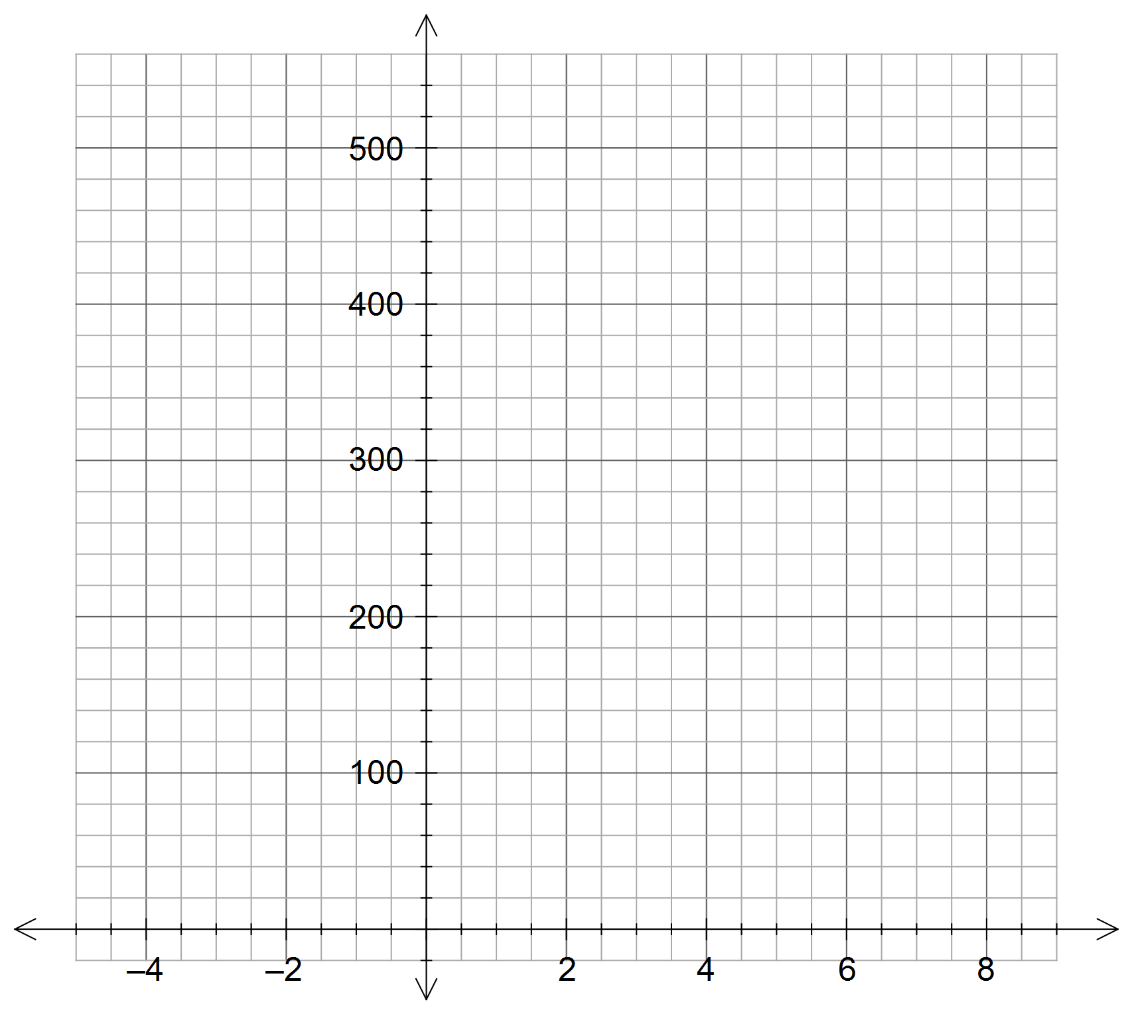

1. What is the significance of the intercept on the y axis?
2. Determine the equation of the line for the relationship between t and C.

(must be in terms of **t** and **c**)

1. What is the significance of the Gradient?
2. Use your graph to answer the following questions

**i)** How much would Amber charge for working 6 hours?

**ii)** How long has Amber worked if she charges $360?